**Radon Measurement Assessment Report**

**Mill Run Apartments**

**PASS Project #: 23-101**

**Prepared for:**

**LCJ Construction**

**P.O Box 489**

**New Caney, Texas 77357**

P

PASS Associates, Inc.

**Report Prepared by**

PASS Associates, Inc.

2221 Justin Road, #119-431

Flower Mound, Texas 75028

214-461-8743



**TABLE OF CONTENTS**

1. **Introduction**
2. **Measurement Assessment Summary, Function, and Placement**
3. **Conclusion & Limitations**
4. **Recommendations**
5. **Radon Assessment Results**

**By Alpha Energy Labs**

**Appendix A- Lab Report**

**Introduction**

This assessment report was developed by PASS Associates, Inc. specifically for the radon measurement sampling conducted at Mill Run Apartments (800 Mill Run Circle. Elkhart, Tx). The measurement was conducted in accordance with the document Protocol for Conducting Radon and Radon Decay Product Measurements in Multifamily Buildings (ANSI/AARST MAMF 2017) by Darryl Carter and Marty Flanders.

Radon is a colorless, odorless, radioactive gas formed through the decay of uranium. Trace amounts of uranium is present in all soil, and radon is found all over the planet. Most of this gas remains underground, but a small percentage migrates to the surface. Most radon is diluted in the atmosphere to very low concentrations but can build up to high concentrations in buildings. The amount of radon intruding into a building depends on the strength of the source, preferential pathways into the building, and a driving force (usually the thermal stack effect of the building). While two buildings may be identical, each site is unique. The only way to know what the radon levels are inside a building is through measurement. Two structures side-by-side can have totally different radon levels. Radon is the second leading cause of lung cancer in the general population and the leading cause of lung cancer among non-smokers. Radon exposure is the cause of approximately 21,000 U.S. lung cancer deaths each year. This risk is largely preventable through testing and mitigation.

For more information on radon, please contact:

The US Environmental Protection Agency at 1-800-767-7236 or visit their website at https://www.epa.gov/radon.

**Measurement Assessment Summary, Function, and Placement**

1. **Measurement Assessment Summary**

The initial measurement was conducted between November 20 and November 22, 2023, for 48 hours and was requested as part of a due diligence project being conducted by the client. A total of 26 measurement devices were deployed in 25 residential homes at Mill Run Apartments were included in the measurement and quality assurance project plan. For quality assurance purposes, 1 duplicate measurement devices were deployed.

Additionally, conformation measurement devices were deployed on December 18th and collected on December 20th, 2023 to confirm the results of six (6) residential homes with elevated levels of radon. All devices were sent under appropriate chain of custody to a qualified analytical laboratory for analysis. For quality assurance purposes, a duplicate measurement device was deployed in each unit.

1. **Measurement Devices**

Short Term Radon Test kits (devices) manufactured by Alpha Energy Laboratories were utilized for the measurement. These Radon test kits utilize activated charcoal as an adsorption material to collect the Radon. Once the required exposure has been completed all the devices were forwarded under appropriate chain of custody for analysis by Alpha Energy Laboratories an analytical laboratory credentialed by the NRPP. Each device was deployed in accordance with the instructions provided by the manufacturer.

The chain of custody for measurement devices is available on request.

2501 Mayes Road, Suite 100

Carrollton, TX 75006

(972)-242-2479

1. **Measurement Placement**

The occupant of each location at the property was notified of the required measurement conditions to be maintained during the testing event prior to device placement. The field professional also delivered notification of the required measurement conditions applicable to the testing event at the time of device placement. In addition, the responsible party for the overall testing event was notified of the required measurement conditions to be maintained during the testing event prior to device placement. Each device was placed about a foot above ground. Special placement of radon samplers were utilized in homes in which pets or young children were present.

**Conclusion & Limitations**

The sole purpose of this assessment is to provide the client with information regarding the indoor radon concentrations at the property at the time of the measurement. An uncertainty with any test result due to statistical variations and other factors, such as daily and seasonal variations in indoor radon concentrations, does exist. Variations may occur due to changes in weather conditions, building usage or possible unobserved interference with the required measurement conditions. Locations not occupied, able to be occupied or inaccessible at the time of the measurement were not tested. Any location not occupied, able to be occupied or inaccessible at the time of the measurement should be tested to ensure radon levels are below the EPA action level prior to future occupancy or upon accessibility, as applicable. The findings and recommendations contained within this report are derived from information obtained from the client and their designated representative, the on-site activities and analytical services provided under the scope of work performed. No representation is made in this report regarding the operational status or proper operation of any mitigation system(s) that may be installed at the property. This measurement assessment report was prepared solely for the use of the client. Use of this report by any party other than is prohibited without prior written consent from PASS Associates, Inc.

**Recommendations**

When a location is indicated to have radon levels below the EPA action level of 4.0 pCi/L:

1. If the location is indicated to have radon levels below the EPA action level of 4.0 pCi/L but at or above 2.0 pCi/L, consider mitigation of the building.
2. When the initial measurement is conducted under non-heating season conditions, follow-up measurement of all buildings under heating season at the earliest opportunity, and no later than 5 years after the initial measurement is recommended.
3. A follow-up measurement is recommended at least every 5 years and in conjunction with the sale of a building(s); a new addition is constructed or significant alterations occur; a ground-contact location not previously tested is occupied; HVAC systems are altered with resulting changes to air distribution or pressure relationship; ventilation is altered by extensive weatherization or changes to mechanical systems; sizeable openings due to ground water or slab surface water control systems are added or altered; natural settlement causing major cracks develops; earthquakes or construction blasting occur nearby; a mitigation system is altered, repaired or modified.

**Based on the information provided and analytical results in appendix A. The EPA requires mitigation for the following units (Apt. 7, Apt. 10, and Apt. 38). Additionally PASS Associates, Inc. recommends mitigation of unit 44 at Mill Run Circle, with a site retest every 3-5 years to monitor Radon Levels.**

**Radon Assessment Results**

The EPA Action Level is any result greater than 4.0 pCi/L. The U.S. indoor average is 1.3 pCi/L, and the outdoor average is 0.3 pCi/L. If your results are greater than 4.0, take action to reduce the radon level. This may include re-testing. Check the EPA website at to determine the

necessary steps.

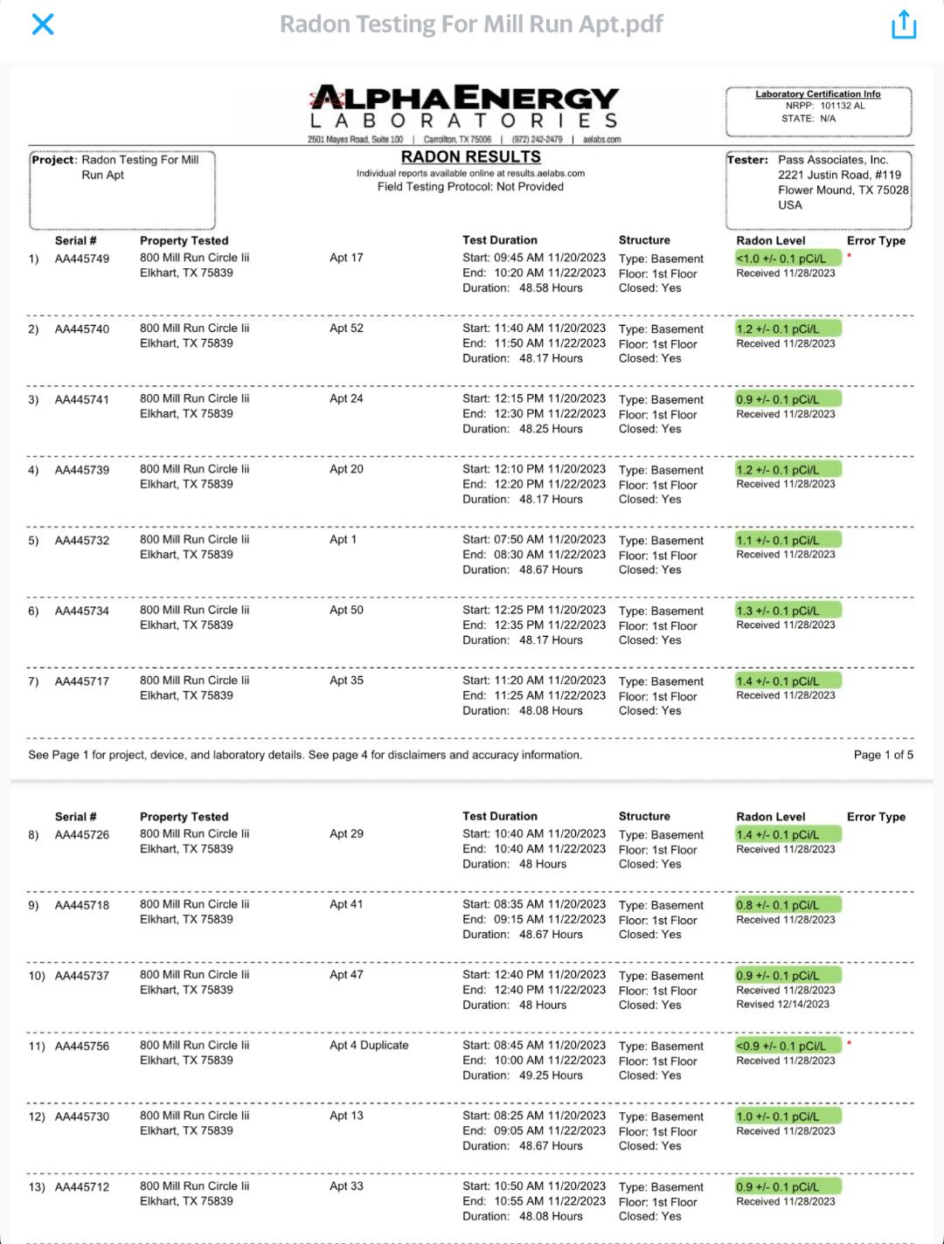

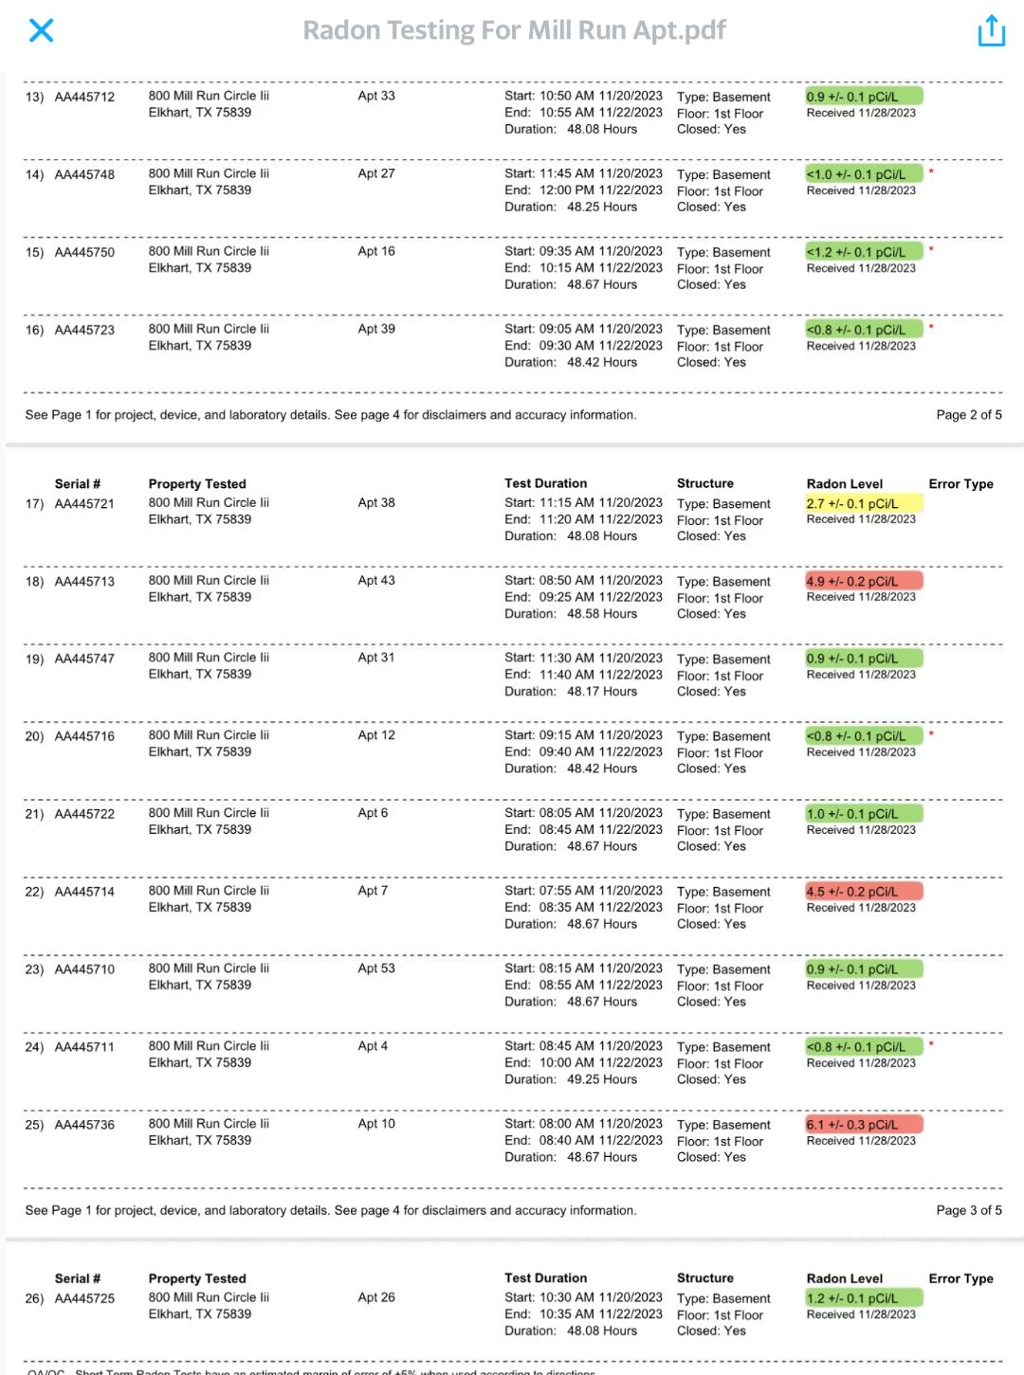

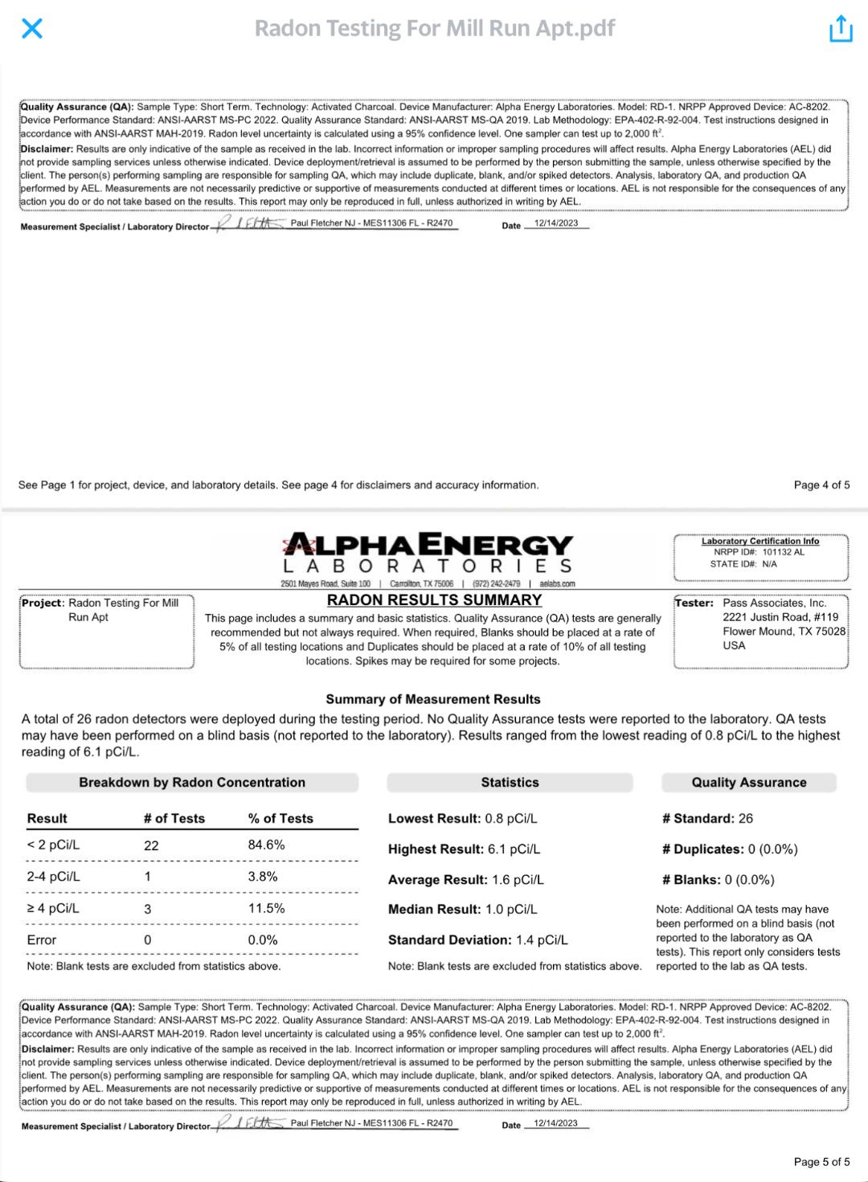**The following units were retested due to elevated Radon Levels:**

